1. Let’s start by understanding when we say **network and requests**.
2. Let’s try to understand by an **example**:
   1. Suppose we have a container with a running app inside it (that app can be Java, PHP etc).
   2. Now suppose, this app wants to talk to some API running on World Wide Web to send/fetch data from there.
   3. 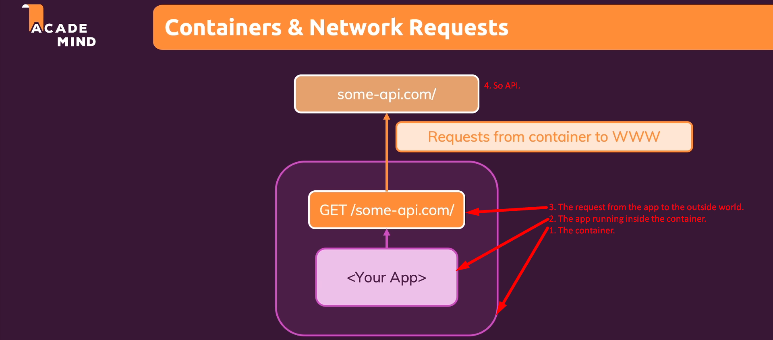
3. Node JS App for Demo Purpose.
   1. Text

      Description automatically generated
   2. So, there is communication b/w the dockerized app and the swapi app running on some other host.
4. So, this is the one case where our app inside the container is sending request to some other app outside the container.   
   And this is the title of the lecture 😊.